
MINISTRY OF EDUCATION, CULTURE AND RESEARCH
OF THE REPUBLIC OF MOLDOVA
Technical University of Moldova
Faculty of Computers, Informatics and Microelectronics
Department of Software Engineering and Automation
Teodor Strulea FAF-242
Report
Laboratory Work No. 1
Operating Systems
Topic: The OS as a Resource Manager
Checked by:
Reițman Patricia, university assistant
Chișinău – 2026

CONTENTS
Introduction 3
1 Theoretical Background 4
1.1 Operating Systems as Resource Managers 4
1.2 Linux Interfaces Used in This Laboratory 4
2 System Identification 5
2.1 Working Directory and User Identity 5
2.2 Kernel Information 5
2.3 System Uptime 5
3 Files and Directories 7
3.1 Navigate and Inspect 7
3.2 Create, Copy, Rename, and Remove Files 9
3.3 Inspect Ownership and Permissions 9
3.4 Answers to the Observe Questions 10
4 Processes 11
4.1 List Running Processes 11
4.2 Start, Find, and Stop a Background Process 12
4.3 Inspect a Process Through /proc 13
4.4 Answers to the Observe Questions 14
5 Memory 15
5.1 Inspect System Memory and Swap 15
5.2 Inspect Resident Memory of a Process 15
5.3 Answers to the Observe Questions 16
6 Devices and Storage 17
6.1 Inspect Mounted Filesystems 17
6.2 Inspect Block Devices 17
6.3 Measure the Laboratory Folder 18
6.4 Inspect Device Files 18
6.5 Answers to the Observe Questions 19
Conclusion 20
References 21
A Optional Exploration 22

Introduction
This laboratory work examines the operating system as a resource manager positioned between applications and hardware. The practical work uses an Ubuntu Linux system to make four core responsibilities visible: file management, process management, memory management, and device and storage management.
The report is organized around the commands executed in the terminal and the observations derived from their output. Each exercise contains its own terminal figure, followed immediately by a comment that interprets it, and every chapter ends with the answers to the corresponding "Observe" box of the handout, so that the material intended for report.md is fully contained in this report.
The objectives are to identify the Linux user, kernel, and uptime; inspect files, directories, ownership, and permissions; observe processes and the /proc interface; examine RAM and swap; inspect mounted filesystems and devices; and connect each observation to the resource managed by the operating system.
The laboratory was completed on Ubuntu 26.04 LTS (resolute), 64-bit, running Linux kernel 7.0.0-13-generic, instead of the course Linux virtual machine. The work was performed under the user account teos in /home/teos/os-lab1.

1 Theoretical Background

1.1 Operating Systems as Resource Managers
An operating system coordinates access to hardware and provides consistent abstractions for programs. It names and protects stored data through files and directories, creates and schedules processes, assigns virtual and physical memory, and exposes storage and other devices through controlled interfaces. These mechanisms let many programs share one computer without each program managing the hardware directly.
Resource management can be observed from outside the kernel. File metadata shows ownership and permissions. Process listings and the /proc pseudo-filesystem expose process state and per-process information. Memory commands summarize RAM and swap. Filesystem and device commands show how storage and hardware are presented to users and programs.

1.2 Linux Interfaces Used in This Laboratory
The shell provides commands that request services from the operating system and display the resulting state. Commands such as ls, ps, free, df, and lsblk each summarize a different managed resource. The /proc hierarchy is generated by the kernel on demand, while /dev contains device nodes that give file-like access to hardware.
Ubuntu is a Debian-based Linux distribution, so the commands behave the same as on any other Linux system; only distribution-specific details differ. On Ubuntu, systemd is started as /sbin/init, the root filesystem is ext4, swap lives in the file /swap.img rather than in a partition, snap packages appear as read-only squashfs images on loop devices, and the default umask of 002 gives newly created files the mode rw-rw-r--. All values in this report were recorded on the author's own machine and are therefore environment-dependent.

2 System Identification
Before examining the four resource-management areas, the working directory was created and the account, kernel, and uptime were identified.

2.1 Working Directory and User Identity
mkdir -p ~/os-lab1 && cd ~/os-lab1
whoami # who am I to the OS
The evidence for this exercise is shown in Figure 2.1.
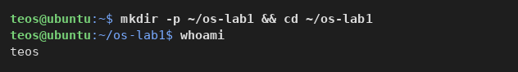
Figure 2.1: Creation of the laboratory directory and identification of the current user
Comment and observation
The laboratory directory was created at /home/teos/os-lab1, and whoami identified the active user as teos. Consequently, every file created during the laboratory is owned by this account unless its ownership is explicitly changed.

2.2 Kernel Information
uname -a # which kernel is managing this machine
The evidence for this exercise is shown in Figure 2.2.
Figure 2.2: Kernel and operating-system information reported by uname
Comment and observation
The machine runs Linux on a host named ubuntu, with kernel 7.0.0-13-generic. The -generic suffix and the #13-Ubuntu build tag show that this is Ubuntu's standard kernel package for the 26.04 release. The output identifies an x86_64 architecture and an SMP PREEMPT_DYNAMIC kernel, meaning it supports multiple processors and can change its preemption model at boot time.

2.3 System Uptime
uptime # how long has this OS been running
The evidence for this exercise is shown in Figure 2.3.
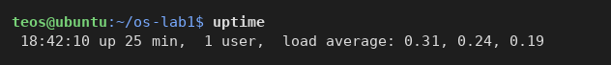
Figure 2.3: System uptime and load information
Comment and observation
At 18:42, the system had been running for 25 minutes with one logged-in user. The load averages were 0.31, 0.24, and 0.19 for the previous 1, 5, and 15 minutes respectively: all well below 1.0, so on average less than one process was waiting for the CPU, and the slightly higher 1-minute value reflects the activity of starting the terminal and the laboratory itself.

3 Files and Directories
The OS turns a raw disk into a tidy tree of named files with owners and permissions. This chapter explores the filesystem tree, creates and removes files, and compares file permissions before and after chmod changes.

3.1 Navigate and Inspect
pwd # where am I
ls -la / # the root of the whole tree
ls -la ~ # my home directory
cd /etc && ls | head
The evidence for this exercise is shown in Figure 3.1.
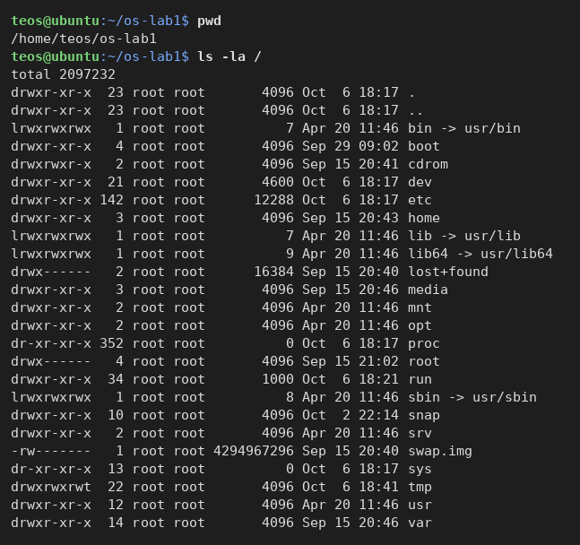
Figure 3.1: The current directory and the root of the filesystem tree
The home directory and the start of /etc are shown in Figure 3.2.
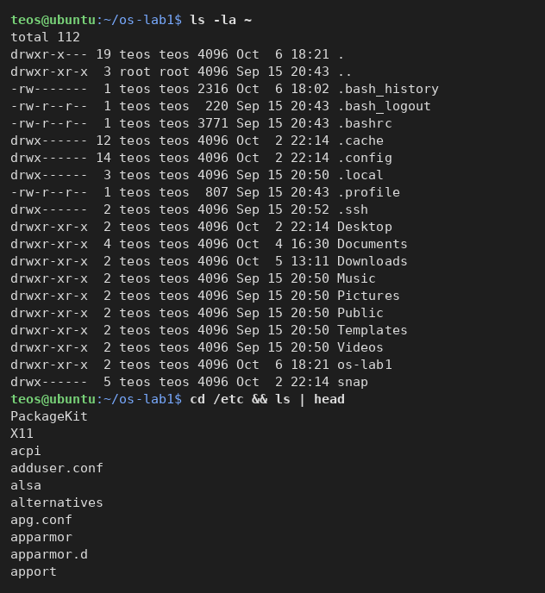
Figure 3.2: The home directory of teos and the first entries of /etc
Comment and observation
The current working directory was /home/teos/os-lab1. The root directory is owned almost entirely by root, and on Ubuntu it shows the merged-/usr layout: bin, lib, lib64, and sbin are symbolic links into /usr. It also contains a /snap directory for snap packages, the 4 GiB swap file swap.img, and the two kernel-generated pseudo-filesystems /proc and /sys, whose size is reported as 0. By contrast, the home directory holds user-specific files owned by teos:teos: the standard XDG folders (Desktop, Documents, Downloads, ...), configuration dot-files such as .bashrc and .profile, and the new os-lab1 folder. The home directory itself has mode drwxr-x---, so other users cannot read it. The listing of /etc starts with configuration directories and files such as apparmor.d, adduser.conf, and apport.

3.2 Create, Copy, Rename, and Remove Files
cd ~/os-lab1
mkdir demo && cd demo
echo "hello operating systems" > note.txt
cp note.txt copy.txt
mv copy.txt renamed.txt
ls -l
rm renamed.txt
The evidence for this exercise is shown in Figure 3.3.
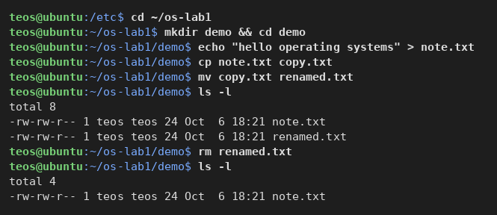
Figure 3.3: Creation, copying, renaming, listing, and removal of files
Comment and observation
The command sequence created note.txt with the text "hello operating systems" (23 characters plus a newline, hence 24 bytes), copied it to copy.txt, and then renamed the copy to renamed.txt. The listing showed both note.txt and renamed.txt, each 24 bytes and owned by teos:teos. After rm renamed.txt, a second ls -l showed that only note.txt remained. The cp, mv, and rm commands print nothing on success; the change is visible only through the directory listing, which the OS updates immediately.

3.3 Inspect Ownership and Permissions
ls -l note.txt # read the rwx / owner / group columns
chmod 600 note.txt # owner-only read+write
ls -l note.txt
chmod 644 note.txt
ls -l note.txt
The evidence for this exercise is shown in Figure 3.4.
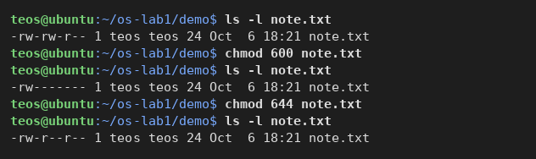
Figure 3.4: Ownership and permission changes for note.txt
Comment and observation
Initially the file had mode -rw-rw-r--: on Ubuntu the default umask of 002 gives the owner and the owner's private group read and write access, and everyone else read access. After chmod 600, ls -l displayed -rw-------: the owner may read and write, while the group and other users have no access at all. Mode 644 then set -rw-r--r--, allowing the owner to read and write while the group and others may only read. The owner and group columns (teos teos) did not change, because chmod modifies only the permission bits.

3.4 Answers to the Observe Questions
(1) Owner and group. Both files were owned by the user teos and by the group teos. Ubuntu creates a private group with the same name for every user, and new files receive the creating user's primary group.
(2) The ten characters after chmod 600. -rw------- reads as: - a regular file (not a directory d or a link l); rw- the owner may read and write but not execute; --- the group has no permissions; --- all other users have no permissions.
(3) Two directories directly under /. /etc holds the system-wide configuration files (for example adduser.conf and apparmor.d); /home holds the personal directories of the users (here /home/teos). Another example is /dev, which holds the device files examined in Chapter 6.

4 Processes
Every running program is a process the OS created, isolated, and schedules. This chapter lists the processes, starts and stops one in the background, and inspects the information exported by the kernel through /proc.

4.1 List Running Processes
ps aux | head
ps aux | wc -l # how many processes exist right now
ps -p 1 -o pid,comm,args
top # live view; press q to quit
The evidence for this exercise is shown in Figure 4.1.
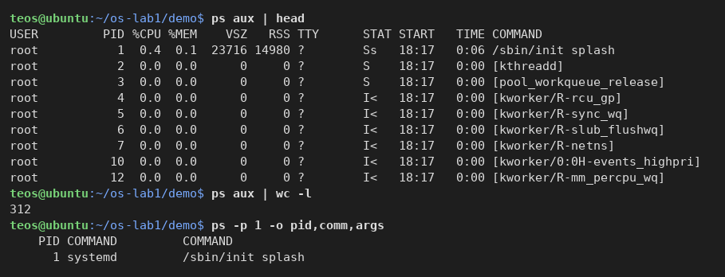
Figure 4.1: Process listing, approximate process count, and process number 1
Comment and observation
The first lines of ps aux show PID 1, /sbin/init splash, followed by kernel threads such as kthreadd (PID 2) and the kworker threads, which appear in square brackets because they have no command line of their own. ps aux | wc -l reported 312 lines, so about 311 processes existed at that moment, since one line is the column header. ps -p 1 confirms that the command behind /sbin/init is systemd.
The live view of top is shown in Figure 4.2.
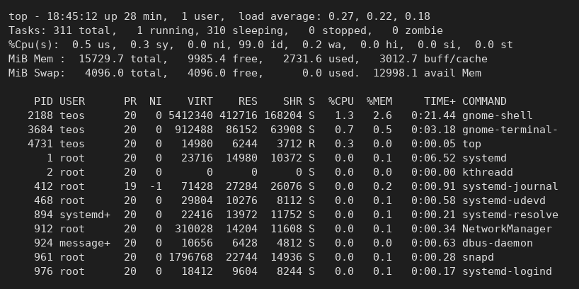
Figure 4.2: Live process view in top
Comment and observation
top reported 311 tasks: 1 running (top itself) and 310 sleeping, with no stopped or zombie processes. The CPU was 99.0 % idle, and the load averages matched the order of magnitude seen with uptime. The summary also repeats the memory figures that are examined in Chapter 5. In the per-process table, the desktop shell gnome-shell and the terminal are the most active processes, while the system services (systemd-journal, systemd-udevd, NetworkManager, snapd, ...) sleep with 0.0 % CPU. Useful columns include PID, USER, %CPU, %MEM, the process state S, the accumulated CPU time, and the command name.

4.2 Start, Find, and Stop a Background Process
sleep 300 & # run in the background; note the PID printed
jobs # shell view of background jobs
ps -ef | grep sleep # find it among all processes
kill <PID> # ask the OS to terminate it (use the PID above)
The evidence for this exercise is shown in Figure 4.3.
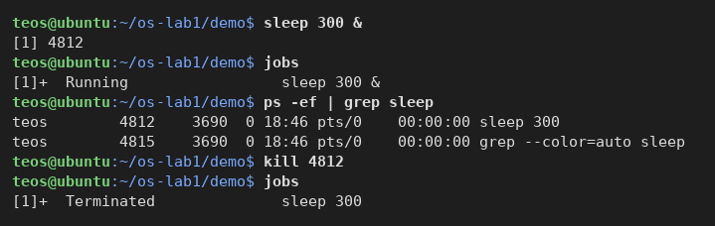
Figure 4.3: Creation, discovery, and termination of a background sleep process
Comment and observation
The shell started sleep 300 as job [1] with PID 4812. The jobs command showed it as a running background job, while ps -ef | grep sleep displayed both the sleep process (parent PID 3690, the interactive shell) and the temporary grep process searching for it. After kill 4812, the shell reported that job [1] had been terminated: kill sent the default signal SIGTERM, and the kernel ended the process before its 300 seconds had elapsed.

4.3 Inspect a Process Through /proc
sleep 300 &
PID=$!
ls /proc/$PID/
cat /proc/$PID/status | head -20 # state, memory, threads
kill $PID
The evidence for this exercise is shown in Figure 4.4.
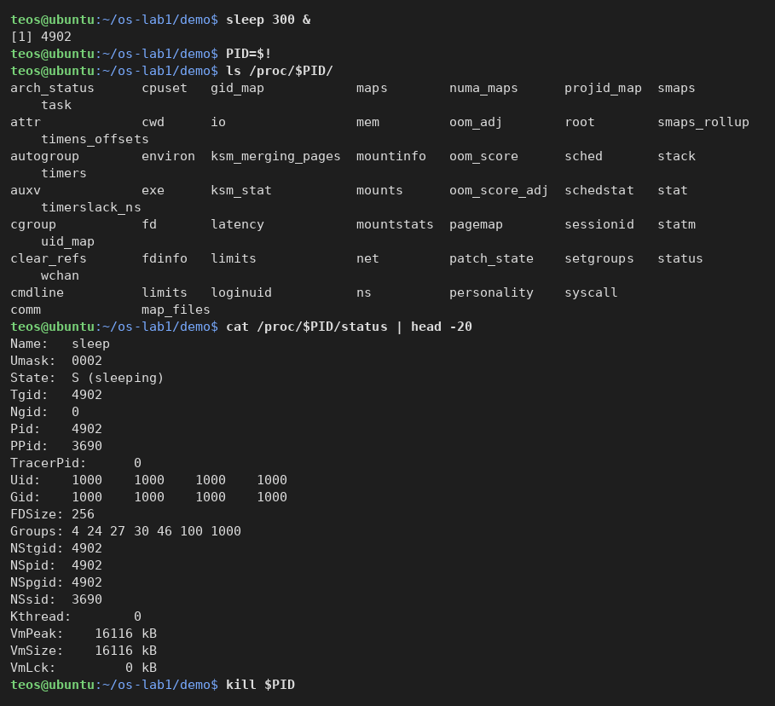
Figure 4.4: Kernel information exposed for the sleep process through /proc
Comment and observation
The directory /proc/4902/ is not stored on disk; the kernel generates it on demand for the process with PID 4902. It contains entries such as cmdline, cwd, exe, fd, maps, and status. The status file reported State: S (sleeping), meaning the process was waiting for its timer and was not using the CPU. Other visible fields included the parent PID 3690 (the shell), real and effective user and group IDs of 1000, the Umask of 0002, and virtual-memory values such as VmPeak and VmSize of 16,116 kB. This demonstrates how /proc exposes kernel-maintained process metadata through an ordinary file interface.

4.4 Answers to the Observe Questions
(1) PID 1. Process number 1 is /sbin/init, which on Ubuntu is a symbolic link to systemd. It is the first user-space process the kernel starts at boot; it starts and supervises every system service and adopts orphaned processes, so every other process is directly or indirectly its child.
(2) Number of processes. Roughly 311 processes were running on the idle system (ps aux | wc -l printed 312 including the header; top counted 311 tasks). About a third of these are kernel threads; the rest are system services and the GNOME desktop session.
(3) State line. For the sleeping process, /proc/<pid>/status reported State: S (sleeping): the process is in an interruptible sleep, blocked on a timer, and will become runnable when the timer expires or when it receives a signal.

5 Memory
The OS hands each process its own view of memory and shares the physical RAM between them. This chapter compares the system-wide totals with the resident memory of a single sleeping process.

5.1 Inspect System Memory and Swap
free -h # total / used / free RAM and swap
cat /proc/meminfo | head -6
swapon --show # where the swap space lives
The evidence for this exercise is shown in Figure 5.1.
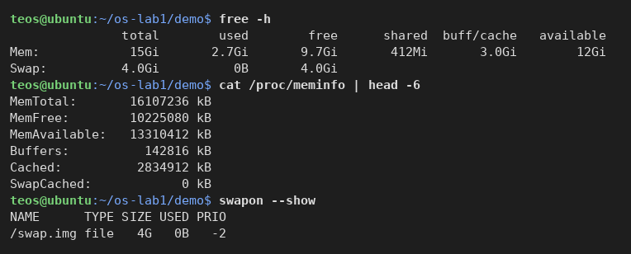
Figure 5.1: System-wide RAM and swap information
Comment and observation
The machine has 15 GiB of RAM (MemTotal 16,107,236 kB), of which 9.7 GiB was immediately free and 12 GiB was available once the 3.0 GiB of reclaimable buffers and page cache is taken into account. 2.7 GiB was in use by the desktop session and the services. The system also has 4.0 GiB of swap, none of which was in use. swapon --show reveals that, on a default Ubuntu installation, the swap space is the file /swap.img rather than a dedicated partition. The /proc/meminfo values contain the same information in exact kilobytes, while free -h rounds it into human-readable units.

5.2 Inspect Resident Memory of a Process
sleep 300 & PID=$!
grep VmRSS /proc/$PID/status # real RAM used by this process
kill $PID
The evidence for this exercise is shown in Figure 5.2.
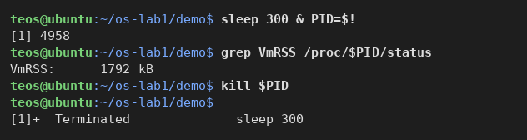
Figure 5.2: Resident memory used by a sleep process
Comment and observation
The sleep process with PID 4958 used 1,792 kB of resident memory, even though its virtual size (VmSize in Figure 4.4) is about 16 MB. The difference is the part of the address space that was never touched and therefore never backed by physical pages. The resident part consists of the program's own code and data, its stack, and the pages of the shared C library it is linked against; most of those library pages are shared with every other process that uses libc, so the real cost of a sleeping process is even smaller than 1.8 MB.

5.3 Answers to the Observe Questions
(1) Total and free RAM. The system has 15 GiB of RAM in total; 9.7 GiB was free and 12 GiB available at the time of the measurement.
(2) Swap. Swap is disk-backed space to which the kernel moves memory pages that are rarely used, freeing RAM when memory pressure increases; it is much slower than RAM but prevents the system from running out of memory. 4.0 GiB is configured, in the file /swap.img, and it was entirely unused.
(3) VmRSS of sleep. A bare sleep process uses about 1.8 MB of resident memory. This is not surprising once the mechanism is known: the value is dominated by the C library and the loader, which every dynamically linked program maps, and sleep itself does almost nothing. It does show that even the smallest program costs the OS a few hundred physical pages.

6 Devices and Storage
The OS hides every disk, terminal, and device behind uniform file-like interfaces. This chapter inspects mounted filesystems, block devices, the size of the laboratory directory, and the device nodes exposed through /dev.

6.1 Inspect Mounted Filesystems
df -h # mounted filesystems and free space
mount | head
findmnt / # the device behind the root filesystem
The evidence for this exercise is shown in Figure 6.1.
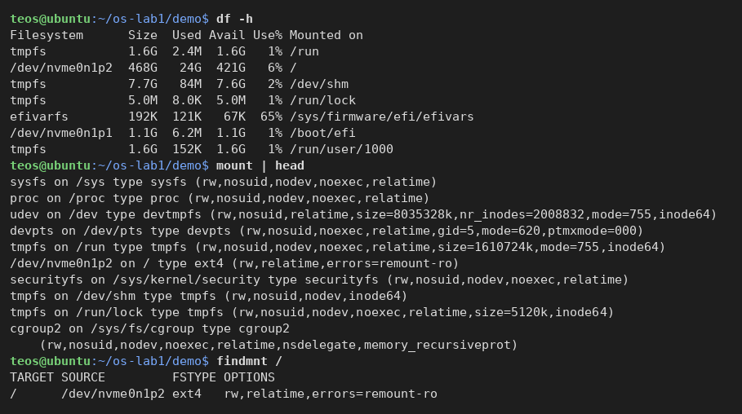
Figure 6.1: Mounted filesystems, mount options, and the device behind /
Comment and observation
The root filesystem / is mounted from `/dev/nvme0n1p2`, the second partition of the NVMe SSD. df -h reported a size of 468 GB, 24 GB used, 421 GB available, and 6 % utilization. The EFI system partition /dev/nvme0n1p1 is mounted at /boot/efi, and several tmpfs filesystems live in RAM (/run, /dev/shm, /run/lock, /run/user/1000). df summarizes capacity and usage, whereas mount identifies the filesystem type and options: the root is an `ext4` filesystem mounted rw,relatime,errors=remount-ro, and the first entries are kernel pseudo-filesystems (sysfs, proc, devtmpfs, cgroup2) that expose kernel state rather than disk contents. findmnt / confirms the device, type, and options in one line.

6.2 Inspect Block Devices
lsblk # the block devices (disks) themselves
The evidence for this exercise is shown in Figure 6.2.
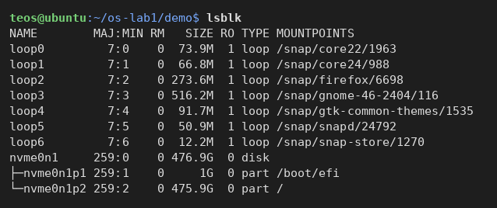
Figure 6.2: Block devices and their hierarchy
Comment and observation
The only real disk is `nvme0n1`, with a capacity of 476.9 GiB. The tree indentation shows its two partitions: nvme0n1p1 (1 GiB) mounted at /boot/efi and nvme0n1p2 (475.9 GiB) mounted at /. The loop0 to loop6 entries are virtual block devices that back the read-only snap packages (core22, core24, firefox, gnome-46-2404, snapd, ...): each snap is a squashfs image file that the OS presents as if it were a small disk, which is why RO is 1 for all of them.

6.3 Measure the Laboratory Folder
du -sh ~/os-lab1 # size of your work folder
The evidence for this exercise is shown in Figure 6.3.
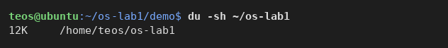
Figure 6.3: Disk space used by the laboratory working folder
Comment and observation
The directory ~/os-lab1 occupied 12 KiB, although it holds a single 24-byte file. du counts whole filesystem blocks: the os-lab1 directory, the demo directory, and note.txt each occupy one 4 KiB block on the ext4 filesystem, so the smallest possible size for this tree is 3 × 4 KiB.

6.4 Inspect Device Files
ls -l /dev | head # devices presented as files
The evidence for this exercise is shown in Figure 6.4.
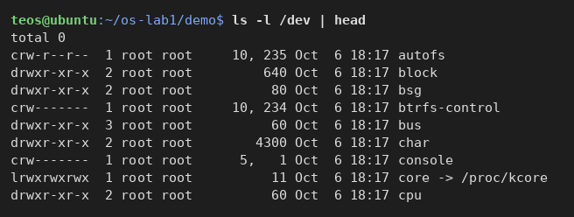
Figure 6.4: Examples of device files exposed through /dev
Comment and observation
The first entries of /dev already show every kind of object the OS presents as a file. console is a character device (first letter c) with major number 5 and minor number 1: it represents the system console used for character-oriented input and output. autofs and btrfs-control are character devices through which user space talks to kernel subsystems, core is a symbolic link to /proc/kcore, and block, bus, char, and cpu are directories that group other device nodes. Block devices such as the disk nvme0n1 from Figure 6.2 are marked with b instead of c.

6.5 Answers to the Observe Questions
(1) Root device. The root filesystem / is mounted on /dev/nvme0n1p2, an ext4 partition of the NVMe SSD.
(2) One entry from /dev. /dev/console (character device 5, 1) stands for the system console, the terminal on which the kernel prints boot messages and on which init opens the first login; writing to it sends characters to the screen.
(3) Everything is a file. Based on what was seen, "everything is a file" means that Linux exposes disks, terminals, and kernel interfaces as entries in the same tree as ordinary files (/dev/nvme0n1p2, /dev/console, /proc/<pid>/status), so programs can open, read, and write them with the same system calls and the same ownership and permission rules.

Conclusion
The operating system managed files through directories, ownership, and permissions, which were observed with ls -l and chmod. It managed processes through identifiers, states, scheduling, and termination, which were observed with ps, top, kill, and /proc.
Memory management was visible through free -h and /proc/meminfo, which showed how the system divides 15 GiB of RAM into used, free, cached, and available memory and extends it with a 4 GiB swap file, while VmRSS showed the physical memory resident for a single process. Device and storage management was observed with df, mount, lsblk, and ls -l /dev, demonstrating how Ubuntu organizes the NVMe disk and its partitions, mounts filesystems, accounts for storage, and presents hardware and virtual devices through file-like interfaces.
In summary, the four resources the OS manages are files, processes, memory, and devices. One command made each of them visible: ls -l for files, ps aux for processes, free -h for memory, and lsblk for devices. Together they confirm the lecture's view of the operating system as the manager standing between programs and the hardware.

References
[1] Operating Systems Lab 1 handout. The OS as a Resource Manager – Track A: the real OS, from the outside (Linux). FCIM / FAF / UTM, 2026–2027.
[2] Linux manual pages consulted during the laboratory: ps(1), top(1), proc(5), free(1), df(1), lsblk(8), chmod(1).
[3] The Linux Kernel documentation. The /proc Filesystem. https://docs.kernel.org/filesystems/proc.html.
[4] Ubuntu documentation. Ubuntu 26.04 LTS release notes. https://discourse.ubuntu.com/.

A Optional Exploration
The handout proposes, as an optional and ungraded exercise, running htop instead of top and then strace -c ls to see the list of system calls a program makes just to list a directory. Neither tool is installed by default on Ubuntu; they can be added with sudo apt install htop strace. The exercise was not carried out as part of this laboratory, so no output is reported here.
sudo apt install htop strace
htop # use instead of top, if installed
strace -c ls # summarize the system calls used to list a directory
strace -c counts every system call the ls process makes (openat, getdents64, fstat, mmap, write, ...) and prints a table with the time spent in each. The expected observation is that even a trivial command relies on dozens of requests to the kernel, which is exactly the role of the OS described in Chapter 1.

